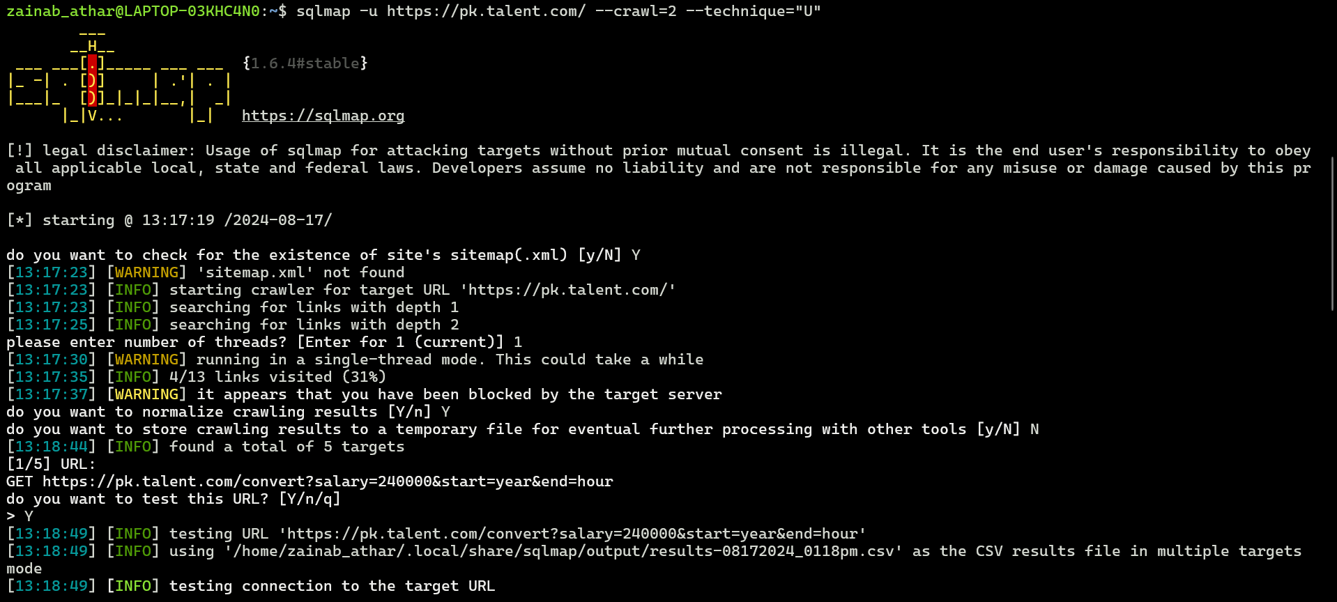

BURPSITE

Creation of Account:



